**Appendix B - Application Flowcharts**

**2. Establishing Protection**

**1. Registration to the App**

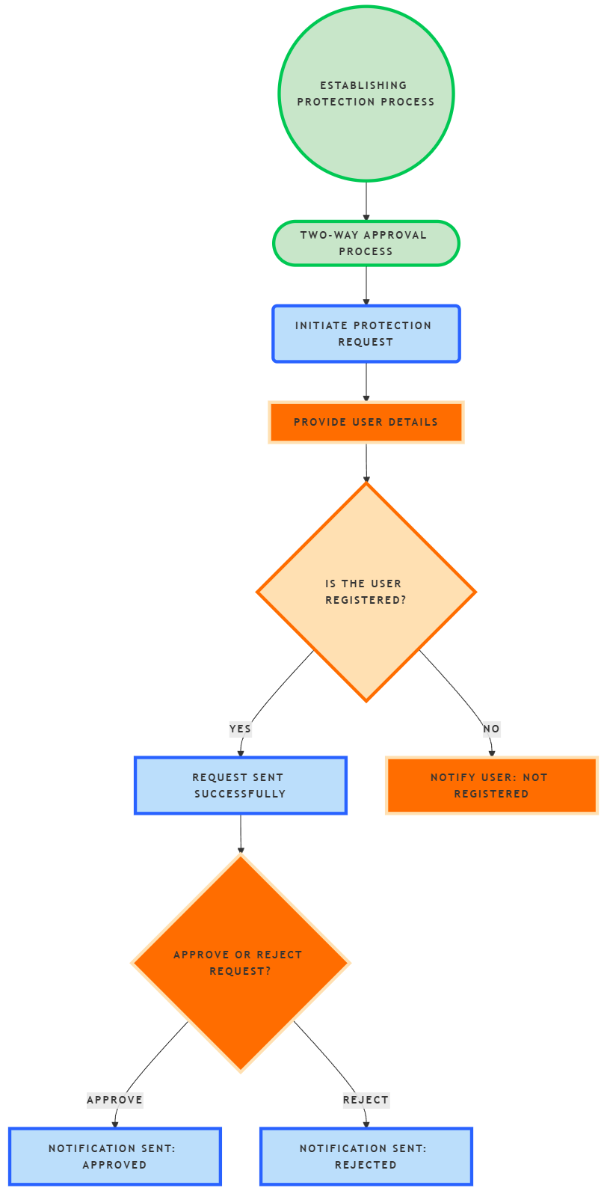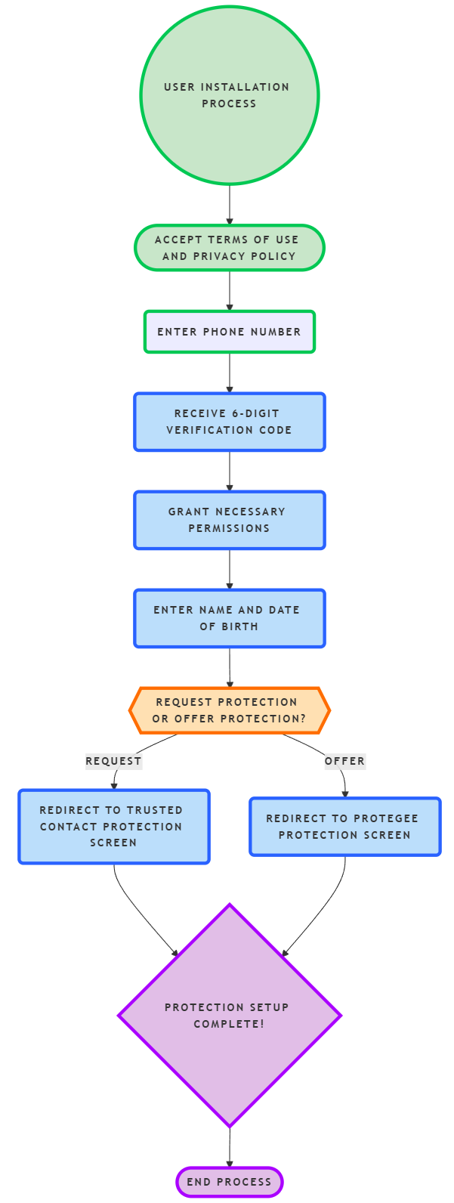

**3. Validation of an Unknown Caller**

**4. Post-Call Scam Detection**

